
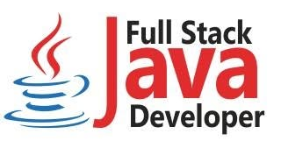

Name: Muhammad Shahrukh
CNIC: 42501-5440822-5
Contact No: 0318-5595230
Program: Blended International IT Trainings (BIITT 2026)
Course: IBM Full‐Stack JavaScript Developer Professional
Center: Viper Technology Innovista Indus IT Park – DHA Phase 2 Ext Karachi
PROJECT PROPOSAL (THE GATEKEEPER)
Enterprise API Gateway Middleware & High-Availability Telemetry Monitor Target Host Platform: Kali Linux. Architecture (Debian Kernel Hardened) Development Stacks: JavaScript Full-Stack (React, Node.js, Express, MongoDB, Docker Microservices)

- Project Overview & Business Value

In mission-critical enterprise environments, system down-time translates directly to massive financial losses and security compromises. Project Gatekeeper is engineered as a high-throughput, low-latency API Gateway and Monitoring Control Room.

It acts as the single point of entry for microservices applications, shielding internal application logic from external threats while offering a real-time, state-driven monitoring interface to track transaction health, latency metrics, and network security logs.

System Integrity Core Directive: Implementing a Zero-Trust data flow architecture where no request is trusted implicitly, requiring cryptographically verified handshakes before processing downstream data operations

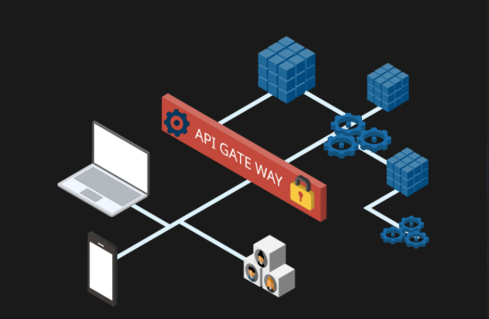
- Technical System Architecture

The system separates the client interaction interface from core background operations using containerized isolation wrappers to manage independent microservice functions efficiently
Architectural Components Breakdowns
- Ingestion & Routing Inceptor (Express.js Engine):
Intercepts all structural incoming endpoints, handles asynchronous JSON payload mapping, and evaluates operational packet health.

- Cryptographic Gatekeeper (JWT Middleware Component):
Validates digital communication tokens dynamically before allowing reads or writes to backend data pathways

- Data Persistence Repository (MongoDB Ledger):
Stores highly granular log details including request origins, millisecond latency measurements, and HTTP response traces.

- Operational Telemetry View (React Interface): A modern dark-themed monitoring interface that displays live status counters, server availability logs, and warning indicators for system failures.

JavaScript Full-Stack Course Inheritance Matrix
Every functional component inside Project Gatekeeper maps directly to the enterprise skill paths outlined within the JavaScript Full-Stack development lifecycle framework.

Full Strack Layer | Core Technology Integration | Applied Mechanism
Presentation Component | React.js (Functional Hooks & State arrays) | Renders dynamic monitoring grids that automatically update when server status changes
Logic & Routing Server |  | Executes concurrent asynchronous tasks to prevent communication timeout blockages
Data Persistence Engine | MongoDB / Mongoose ODM Data Drivers | Manages real-time log ingestion arrays with automatic data validation schemas.
DevOps Isolation Container | Docker Virtualized Bridge Networks | Sandboxes every microservice separately to secure the environment against cross-contamination threats

- Kali Linux AMD64 Host Deployment Blueprint.

The production configuration leverages the architectural benefits of a Kali Linux AMD64 operating ecosystem. The multi-container system deployment is automated through standardized infrastructure configurations

Infrastructure Automation Directives:

- Platform Target Optimization: Compilation parameters are specifically calibrated for Debian 64-bit systems to maximize throughput stability
- Security Sandboxing Rules: The MongoDB persistence engine is bound entirely to internal docker network bridges, making it invisible to standard network port scans.
Infrastructure Automation Directives:

KALI LINUX AMD64 HARDENED HOST

Docker Network Bridge

REACT FRONTEND UI -- HTTP/JSON -- EXPRESS CORE API
(Port 3000 Container) (Port 5000 Cont.)
│
Isolated TCP Pipe
▼
MONGODB DATABASE
(Port 27017 Cont.)

- Failure Mode Recovery & Logging Logic

To evaluate system resilience under high-latency stress conditions, the backend tracking logs engine handles structural verification arrays natively When a remote endpoint triggers a request anomaly, the log collection system logs the event automatically
{
timestamp : 2026-07-12T11:53:14Z ,
component : Gateway-Core ,
event_type : Handshake_Validation ,
trace_metrics : {
origin_ip : 192.168.x.xx ,
latency_ms: 504,
http_response_code : 504,
status : Gateway Timeout Detected
}
}

Example:

This specific structured logging model allows security administrators to easily spot brute-force attacks or connectivity issues during post-incident forensic audits

